Spring boot with View as

Thymeleaf -🡪 dynamic html

Controller layer

Service layer

Doa layer -🡪 JdbcTemplate

<https://start.spring.io/>

spring boot 3.x version we need minimum version of java 17.

Web starter : for web application

Thymeleaf 🡪 for view

Jdbc starter 🡪 to get features of DataSource or JdbcTemplate

Mysql connector 🡪 mysql database (dependencies)

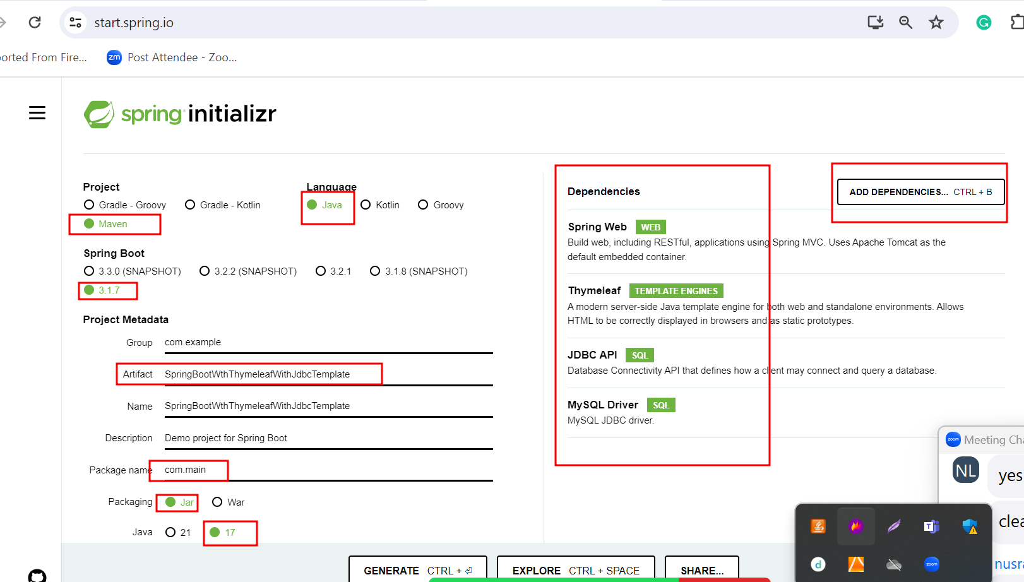

We added jdbc starter.

Spring boot search data base details.

In spring boot we need to write database details like url, username, password and drivername in application.properties files.

From view it html or jsp we are passing the value to controller or servlet.

In servlet or spring controller using HttpServletReqeust object we are receiving the value and doing type casting and then set the value of JavaBean class object.

Application.properties file contains database details.

In Dao layer we done di for JdbcTemplate